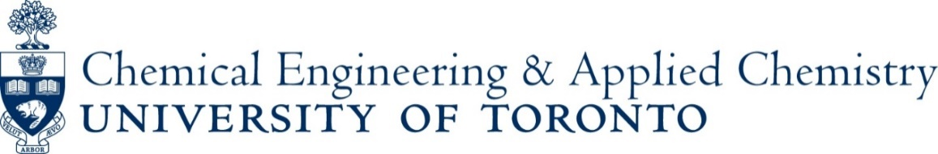

Bridging the Gap Between Research and Application by Use of in situ and operando Vibrational Spectroscopies
Katia Barbera
European Research Institute of Catalysis, University of Messina, Messina, Italy
Monday, October 17, 10:30 AM, WB 407
Abstract: The relationship between catalyst structure, i.e. surface composition at atomic level, and reactivity/selectivity remains the most important question in modern heterogeneous catalysis because such fundamental information would allow for rational design of advanced catalysts, especially at industrial level. It is now well-appreciated that catalyst surfaces are dynamic and are altered by the environmental conditions (T, P, and gas or liquid composition). Consequently, it is critical to establish structure-performance relationships for catalysts operating under real reaction conditions given their dynamics.
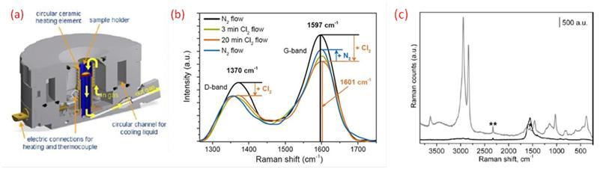
Among all the viable techniques, in situ spectroscopy of heterogeneous catalysts has been recognized a powerful tool and an invaluable approach for characterizing catalytic materials over a wide range of environmental conditions, and especially in the last decades, by coupling time-resolved in situ spectroscopy and online product analysis over catalyst (referred to as operando conditions) it is possible to directly relate the catalyst surface/bulk structure with catalyst performance, more than using other characterization techniques, in a very versatile way.
(a) Detailed sketch of the Linkam CCR1000 reactor with flow indications by arrows to illustrate the fluidization principle (b) In situ Raman spectra of carbon catalysts contacted with Cl₂ at 40°C. (c) In situ Raman spectra of methanol conversion over H-ZSM-5 at 350°C under operando (gray curve) and static (black curve) conditions.
This talk will review some case studies that have been explored by use of vibrational spectroscopy in the last decades, and will show the improvements/ achievements in some of them of industrial relevance, such as from Methanol to Gasoline (MTG) process over zeolites, CO chlorination over nanocarbon catalysts, biomass conversion over microporous and mesoporous materials, metal-supported catalysts for electrochemical CO₂ reduction.

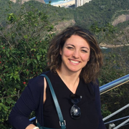
Bio: After obtaining the "Laurea cum Laude" degree in Industrial Chemistry in 2006, Katia was granted by a Fellowship in the Project PRIN 2006 with the work on: “Safe and direct synthesis of H₂O₂ from H₂ and O₂” and then moved to the University of Turin, where under the guidance of Prof. Silvia Bordiga, she received the Doctoral title in Science and High Technology developing a three-years experimental work in the frame of a project coordinated by Haldor Topsøe (Dr. Pablo Beato). In 2011 she was Postdoc Researcher at the Departement Chemie und Angewandte Biowissenschaften in ETH – Eidgenössische Technische Hochschule Zürich (CH). Since 2012, she is Researcher at the European Research Institute of Catalysis at the Chemistry Department in the University of Messina, in the group of Prof. Gabriele Centi and Siglinda Perathoner, carrying the research activity in several EU Projects: ranging from synthesis and characterization of carbon-based membranes for phosgene production and photocatalysts, to synthesis of nanocatalysts for Effective Power to Gas Conversion (methanation), and eco-friendly biorefineries fine chemicals from CO₂ photoelectrocatalytic reduction. In 2013 she was awarded in the National Frame “Energies in the Research”, in the field of renewable sources, for CO₂ conversion and low-impact Energy production.
She collaborates periodically with Haldor Topsøe, Bayertech, Total Energy & Power, Eurecat France for developing novel methodologies for in situ analyses, and works in close collaboration with academic (Universitet I Oslo, Technische Universität München, University of Cosenza, Institute National Council of Research), where part of the research activities she had undertaken was focused on synthesis, testing and characterization of nanostructured materials (zeolites, zeotypes, carbons, metal oxides, metal-supported catalysts) devoted to catalyze reactions of industrial interests. Since August 2016, she is appointed as Visiting Researcher at Lehigh University (Pennsylvania) in the group of Prof. Israel Wachs, to develop new operando technologies for microkinetic studies.
Host: Cathy Chin (cathy.chin@utoronto.ca)

